Practical 7
Definition : Clean Real world Datasets by Handling missing values, Duplicates, and inconsistent, Data across Platforms
Outcomes / Learning : This experiment demonstrates fundamental data analysis and visualization techniques using Python libraries like pandas and matplotlib, including data creation, cleaning (removing duplicates), summary statistics, missing value imputation, and data visualization (bar chart).
Working : The experiment creates a pandas DataFrame, removes any duplicate rows, calculates the mean revenue (for potential future use), summarizes the data's shape and key statistics (mean, mode, standard deviation), visualizes the 'Revenue by Month' using a bar graph, and exports the processed data to an Excel file.

Step 1 : This code imports necessary Python libraries (pandas, openpyxl, and specific classes for charting) and then creates a pandas DataFrame named inzmamkhans_dataframe from a dictionary literal containing simple sample data for 'Product', 'Month', and 'Revenue'.
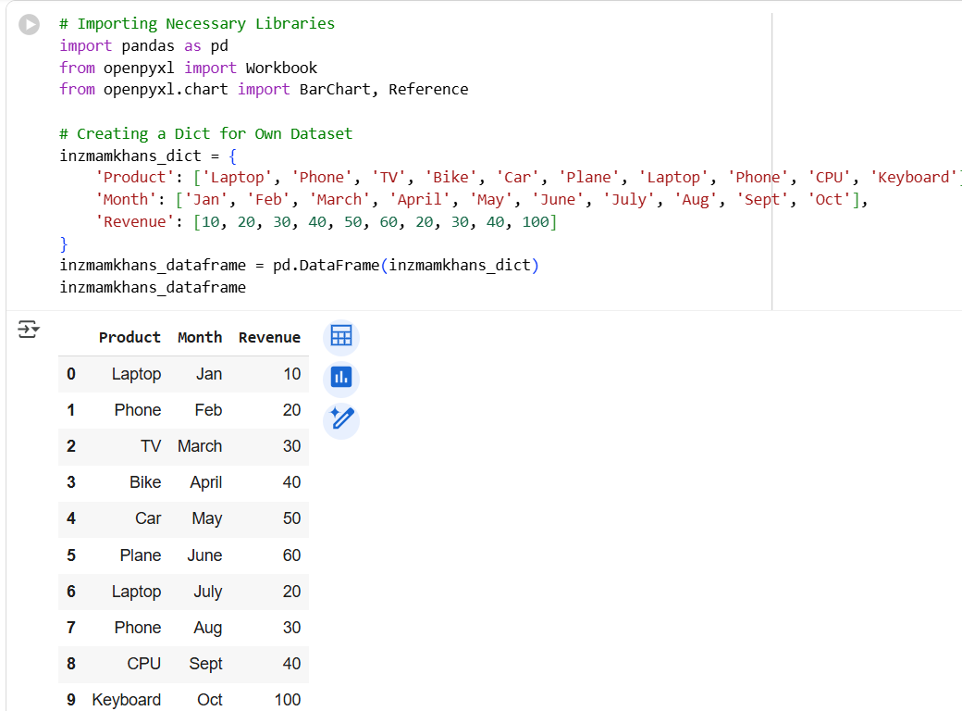
Step 2 : This step removes duplicate rows from the inzmamkhans_dataframe by calling the drop_duplicates() method and then reassigning the cleaned result back to the same variable, effectively showing a DataFrame where any identical rows have been dropped.
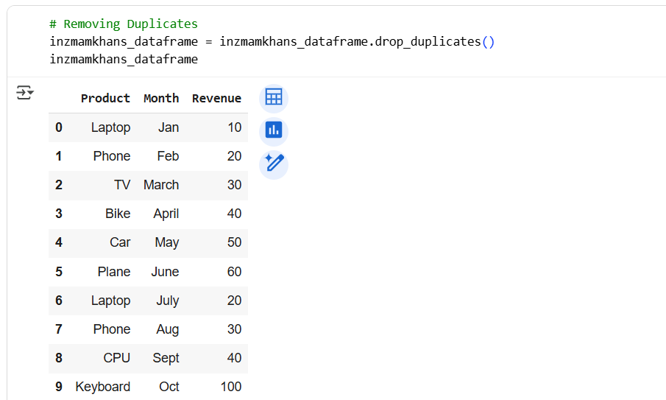
Step 3 : This step calculates the mean of the 'Revenue' column and stores it in the revenue_mean variable, then fills any missing values (NaNs) in the 'Revenue' column of the inzmamkhans_dataframe with this calculated mean using the fillna() method.
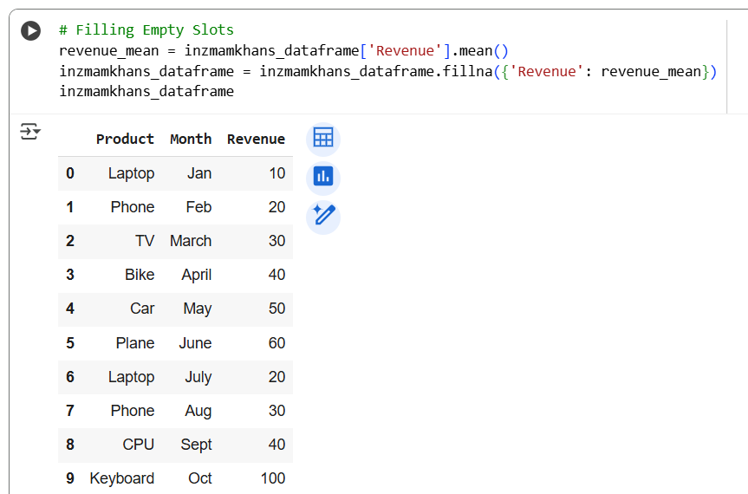
Step 4 : This step summarizes the inzmamkhans_dataframe by printing its shape (number of rows and columns), size (total number of elements), the first few rows using head(), and then calculating and printing the mean, mode, and standard deviation of the 'Revenue' column.
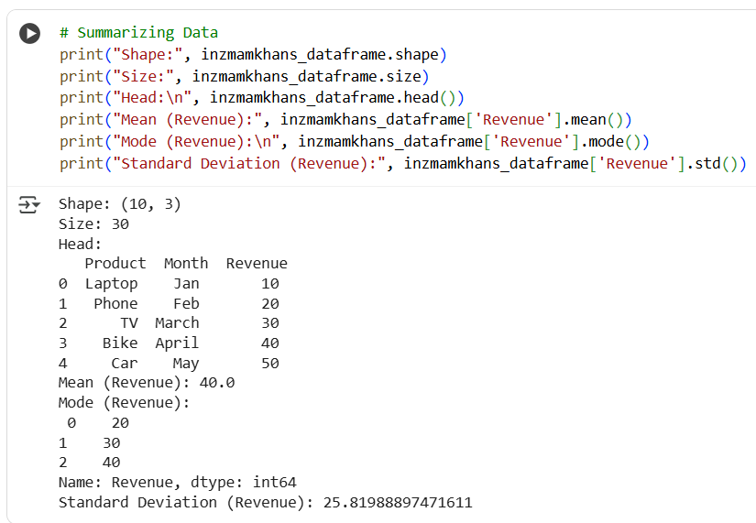
Step 5 : This step imports the matplotlib.pyplot library as plt and then generates a bar graph titled 'Revenue by Month' using the data from inzmamkhans_dataframe, plotting 'Month' on the x-axis and 'Revenue' on the y-axis, setting the bar color to 'skyblue', and finally displaying the plot.
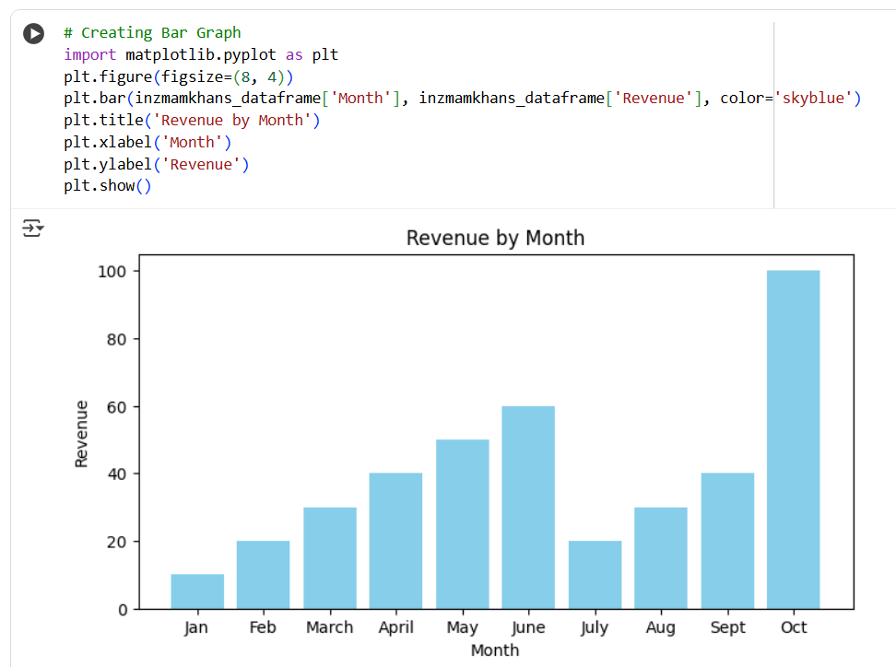
Step 6 : This step creates an Excel workbook using openpyxl by instantiating Workbook() and accessing its active worksheet, names the worksheet "Revenue by Product", iterates through the rows of inzmamkhans_dataframe and appends each row's data as a list to the worksheet, prints the DataFrame's column names (for a check), and finally saves the workbook as "Analytics Lab - Expt 7 - Result Source.xlsx".
